Python does NOT reserve the word self.  You can technically write:  def f(this, x):  print(this.x) | self represents the current object calling the method
Example with multiple objects:  class Person:  def set_name(self, name):  self.name = name  p1 = Person()  p2 = Person()  p1.set_name("Alice")  p2.set_name("Bob") | Person.set_name(p1, "Alice")  Person.set_name(p2, "Bob")So:  self = p1 in first call  self = p2 in second call  This is how Python keeps object data separate
Why MUST we pass self in class methods?Because Python does NOT automatically know:
which object’s data to use
which object’s variables to modify
When you call:  obj.f()  Python automatically does this:  A.f(obj)  This happens before your function body executes | Your code  class A:  def f():  print(x)  obj = A()  obj.f()  What Python actually tries to do  A.f(obj)  But your function definition is:  def f():  That means:  Function expects 0 arguments  Python passes 1 argument (obj)  CRASH happens here  Actual error (important):  TypeError: f() takes 0 positional arguments but 1 was given

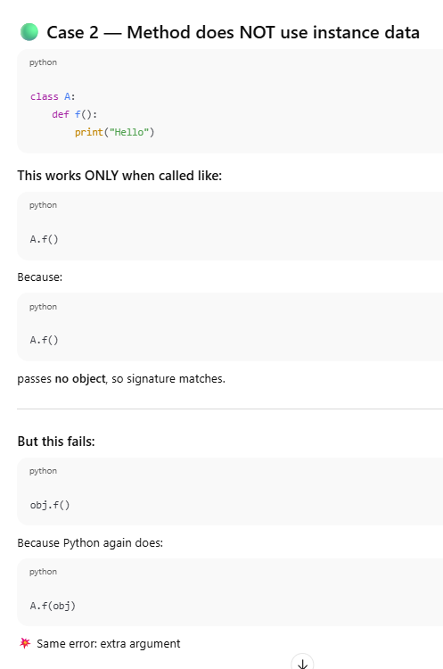

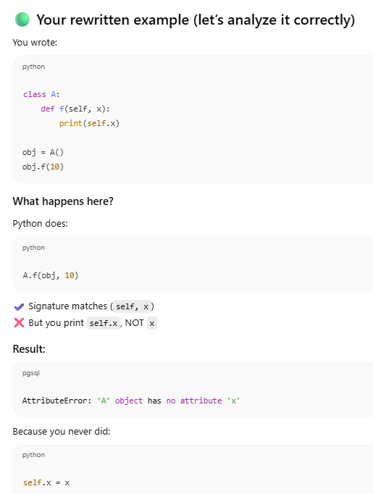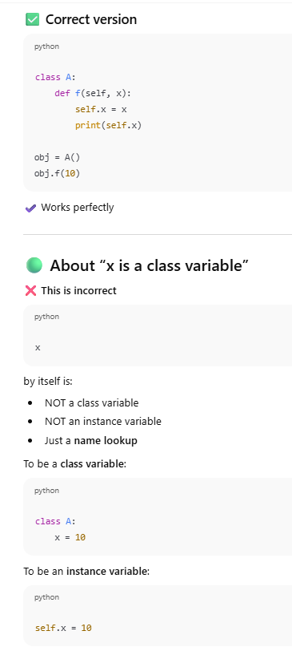

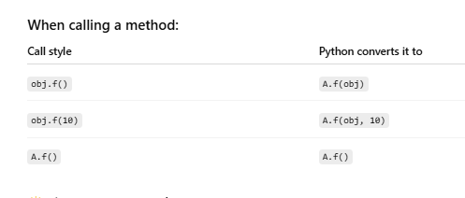

***********************************************************************************************
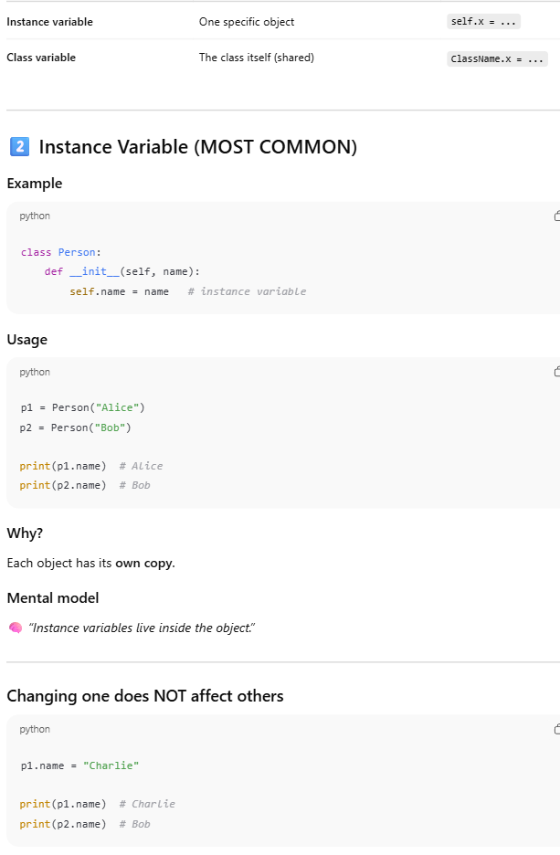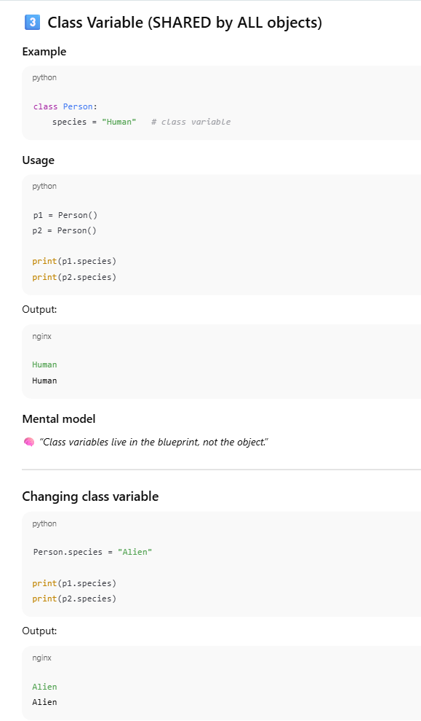

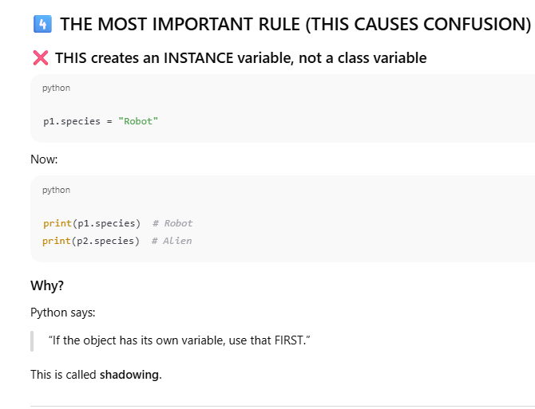

So here you have assigned a value for the object p1 (p1.species=”Robot”) so thats why it is an Instance Variable here.
If you change the value through a class name like Person.species = "Alien", Then it is a CLASS Variable.

When Python sees:
obj.x
It checks in this order:
1️⃣ Instance (obj.__dict__)
2️⃣ Class (Class.__dict__)
3️⃣ Parent classes

we usually define instance variables in __init__
class A:
def __init__(self, x):
self.x = x
✔ Guarantees object always has x
✔ Prevents runtime errors
✔ Professional practice

